

|  |
| --- |
|  |
|  |
|  |
|  |
|  |
|  |
|  |
|  |
|  |

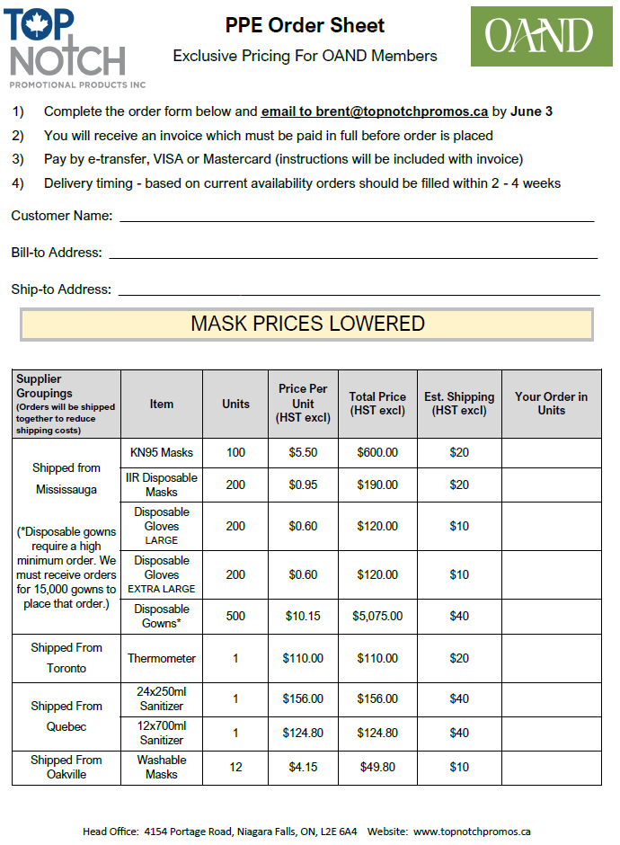

Enter full shipping address – if clinic not open ship to a home address

Enter full billing address

Enter name in this box as you would like it to appear on invoice